

𝐌𝐢𝐜𝐫𝐨𝐬𝐞𝐫𝐯𝐢𝐜𝐞𝐬 𝐑𝐨𝐚𝐝𝐦𝐚𝐩  
  
- 𝐏𝐫𝐨𝐠𝐫𝐚𝐦𝐦𝐢𝐧𝐠 𝐋𝐚𝐧𝐠𝐮𝐚𝐠𝐞𝐬: Choose languages that align with microservices flexibility.  
  
- 𝐃𝐚𝐭𝐚𝐛𝐚𝐬𝐞𝐬 : Select databases designed for scalability and availability.  
  
- 𝐂𝐨𝐧𝐭𝐚𝐢𝐧𝐞𝐫𝐬 : Use containers for isolated, portable environments.  
  
- 𝐌𝐞𝐬𝐬𝐚𝐠𝐞 𝐁𝐫𝐨𝐤𝐞𝐫 : Ensure reliable communication between services.  
  
- 𝐂𝐈/𝐂𝐃 : Automate deployment and updates for efficiency.  
  
- 𝐂𝐥𝐨𝐮𝐝 : Leverage cloud platforms to manage and scale infrastructure.  
  
- 𝐌𝐨𝐧𝐢𝐭𝐨𝐫𝐢𝐧𝐠 : Implement real-time monitoring for performance tracking.  
   
- 𝐒𝐞𝐜𝐮𝐫𝐢𝐭𝐲 : Prioritize security to protect microservices across all layers.



Microservices have transformed how we build apps, and these best practices ensure you get it right:  
Single Responsibility: Each service should focus on one task, making it easier to manage.  
**Separate Data Store:** Keep databases independent to avoid one service's issues from impacting others.  
**Async Communication:** Use message queues to decouple services, ensuring they remain responsive.  
**Containerization:** Package services in Docker, making them portable and scalable.  
Kubernetes Orchestration: Manage your containers easily with Kubernetes, allowing auto-scaling and self-healing.  
Stateless Design: Keep services stateless where possible for easier scaling.  
Following these best practices ensures resilience and adaptability in your microservices architecture. Customize as needed for success!



Choosing the Right API Protocol  
  
In the world of software integration, selecting the appropriate API protocol can make or break your project.   
  
Here's a practical guide to help you navigate the maze of API protocols:  
  
1. Need real-time updates for your web app?  
 → Go for Server-Sent Events (SSE) or WebSocket  
 SSE: One-way real-time updates from server to client  
 WebSocket: Full-duplex communication for truly interactive experiences  
  
2. Building an IoT ecosystem?  
 → MQTT is your friend  
 Lightweight messaging perfect for devices with limited resources  
  
3. Want flexible data querying without multiple API calls?  
 → GraphQL has got you covered  
 Clients can request exactly what they need, nothing more, nothing less  
  
4. Dealing with enterprise systems or legacy integrations?  
 → Consider SOAP or EDI  
 SOAP: Robust protocol for structured data exchange  
 EDI: Standard for business document transfers (invoices, purchase orders)  
  
5. Creating a microservices architecture?  
 → Look into gRPC or AMQP  
 gRPC: Efficient, low-latency communication between services  
 AMQP: Reliable message queuing for distributed systems  
  
6. Need to trigger actions based on events in your system?  
 → Webhooks are the way to go  
 Set up HTTP callbacks to notify external systems about events  
  
7. Building a public API?  
 → REST is still a solid choice  
 Widely adopted, uses standard HTTP methods, great for stateless operations  
  
8. Designing a scalable, event-driven system?  
 → Explore Event-Driven Architecture (EDA)  
 Loosely-coupled components that react to events, great for real-time processing  
  
Remember, there's no one-size-fits-all solution.   
  
The best protocol depends on your specific requirements, scalability needs, and the ecosystems you're integrating with.





REST API Authentication: Securing Your Data in the Modern Web  
  
In today's interconnected world, REST APIs serve as the foundation for countless applications and services. However, with this power comes the critical responsibility of ensuring security. Let’s explore four key authentication methods for securing REST APIs:  
  
1. Basic Authentication:  
- This is the simplest form, where the username and password are sent encoded in base64 with every request.  
- Pros: Easy to implement, widely supported.  
- Cons: Credentials are sent with every call, making it vulnerable unless used with HTTPS.  
- Best suited for internal APIs or development environments, but not recommended for production.  
  
2. Token Authentication:  
- Instead of credentials, temporary tokens are used for each request.  
- Workflow: The client authenticates once, receives a token, and uses it for subsequent requests.  
- Pros: More secure than Basic Authentication, tokens can be revoked, and it reduces server load.  
- Cons: Requires token management and poses security risks if tokens are compromised.  
- Best for most web and mobile applications, including Single Page Applications (SPAs).  
  
3. OAuth Authentication:  
- Allows third-party applications to access resources without sharing passwords.  
- A complex workflow involving multiple steps: request, grant, access token, and refresh token.  
- Pros: Highly secure, ideal for third-party integrations, and offers fine-grained access control.  
- Cons: Can be complex to implement and may be overkill for simpler APIs.  
- Best for APIs that need to integrate with multiple services or allow third-party access.  
  
4. API Key Authentication:  
- Uses a unique key to authenticate and identify API requests.  
- Simple workflow: The client includes the API key in headers or query parameters.  
- Pros: Easy to implement and use, and useful for tracking API usage.  
- Cons: Less secure if keys are exposed and offers limited access control.  
- Best suited for public APIs, developer-focused services, or scenarios where tracking API usage is needed.  
  
Choosing the right authentication method depends on your specific use case, security needs, and target audience. Many modern applications employ a combination of these methods based on different scenarios.  
  
Key Takeaways:  
- Always use HTTPS to encrypt data in transit, regardless of the authentication method.  
- Weigh the trade-offs between security and ease of use.  
- Implement proper token/key management and rotation policies.  
- Stay informed on security best practices and evolving standards

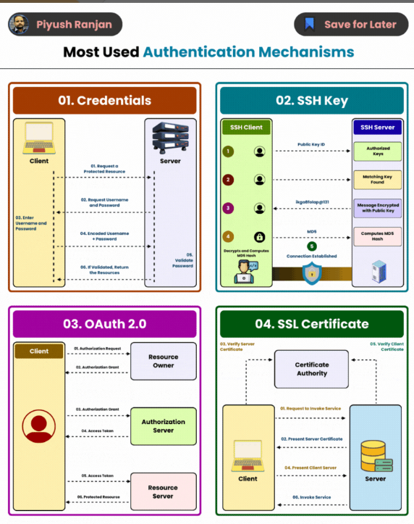



💎 𝐖𝐡𝐚𝐭 𝐢𝐬 𝐭𝐡𝐞 𝐎𝐀𝐮𝐭𝐡 𝟐.𝟎?  
  
⚡ OAuth 2.0 is an authorization framework that enables applications to obtain limited access to user accounts on an HTTP service, such as Facebook, GitHub, or Google. It's designed to work with HTTP and provides authorized access to the user's data without exposing the user's credentials.   
  
⚡ OAuth 2.0 focuses on client developer simplicity while providing specific authorization flows for web applications, desktop applications, mobile phones, and living room devices.  
  
🔥 𝐇𝐨𝐰 𝐎𝐀𝐮𝐭𝐡 𝟐.𝟎 𝐖𝐨𝐫𝐤𝐬?  
🔸 𝐑𝐞𝐬𝐨𝐮𝐫𝐜𝐞 𝐨𝐰𝐧𝐞𝐫:This is the user that knows the credentials to access a particular resource. This is usually a person trying to access a system, In Bizagi this would be a user trying to access the Work Portal.  
  
🔸 𝐂𝐥𝐢𝐞𝐧𝐭: For security reasons, the resource server does not talk directly with the authorization server, so a breach in the communication between the user and the resource server does not expose credentials or secured information. The client then is an additional "application" that wants to access the user account in the authorization server. To do that, the user must give permission, so the client can talk to the authorization server on its behalf.  
  
🔸 𝐑𝐞𝐬𝐨𝐮𝐫𝐜𝐞 𝐒𝐞𝐫𝐯𝐞𝐫: This server hosts the application that the user wants to access. Usually the resource server and the authorization server are embedded in one application or API.  
  
🔸 𝐀𝐮𝐭𝐡𝐨𝐫𝐢𝐳𝐚𝐭𝐢𝐨𝐧 𝐒𝐞𝐫𝐯𝐞𝐫:This server holds the user's accounts and credentials.  
  
✅ 𝐀 𝐟𝐞𝐰 𝐛𝐞𝐧𝐞𝐟𝐢𝐭𝐬 𝐨𝐟 𝐎𝐀𝐮𝐭𝐡 𝟐.𝟎:  
🔹 𝐄𝐧𝐡𝐚𝐧𝐜𝐞𝐝 𝐒𝐞𝐜𝐮𝐫𝐢𝐭𝐲:  
◾ Uses tokens instead of user credentials.  
◾ Compromised tokens have limited impact.  
◾ Tokens can be scoped, limited in duration, and revoked.  
  
🔹 𝐅𝐢𝐧𝐞-𝐠𝐫𝐚𝐢𝐧𝐞𝐝 𝐀𝐜𝐜𝐞𝐬𝐬 𝐂𝐨𝐧𝐭𝐫𝐨𝐥:  
◾Users control the level of access granted to applications.  
◾Adheres to the principle of least privilege.  
  
🔹 𝐁𝐞𝐭𝐭𝐞𝐫 𝐔𝐬𝐞𝐫 𝐄𝐱𝐩𝐞𝐫𝐢𝐞𝐧𝐜𝐞:  
◾Streamlines authorization by eliminating the need for repeated logins.  
◾Offers a smoother interaction with third-party applications.  
  
🔹 𝐒𝐭𝐚𝐧𝐝𝐚𝐫𝐝𝐢𝐳𝐚𝐭𝐢𝐨𝐧 𝐚𝐧𝐝 𝐈𝐧𝐭𝐞𝐫𝐨𝐩𝐞𝐫𝐚𝐛𝐢𝐥𝐢𝐭𝐲:  
◾Widely adopted standard ensures consistent implementation.  
◾Facilitates easier integration and a uniform authorization experience.  
  
🔹 𝐒𝐜𝐚𝐥𝐚𝐛𝐢𝐥𝐢𝐭𝐲:  
◾Token-based architecture simplifies supporting large user bases.  
◾Resource servers validate tokens without managing credentials.  
  
🔹 𝐅𝐥𝐞𝐱𝐢𝐛𝐢𝐥𝐢𝐭𝐲:  
◾Supports multiple grant types for different application scenarios.  
◾Adaptable to web, mobile, and IoT applications.  
  
🔹 𝐃𝐞𝐥𝐞𝐠𝐚𝐭𝐞𝐝 𝐀𝐮𝐭𝐡𝐨𝐫𝐢𝐳𝐚𝐭𝐢𝐨𝐧:  
◾Allows applications to act on a user's behalf with specific permissions.  
◾Useful for actions required when the user is not present.



Top 12 Tips for API Security   
.   
.   
- Use HTTPS   
- Use OAuth2   
- Use WebAuthn   
- Use Leveled API Keys   
- Authorization   
- Rate Limiting   
- API Versioning   
- Whitelisting   
- Check OWASP API Security Risks   
- Use API Gateway   
- Error Handling   
- Input Validation



- API Logging & Auditing: Track API activity to detect suspicious behavior.  
  
- HTTP Encryption: Use HTTPS to secure data transmission.  
  
- Security Headers: Apply headers to prevent attacks like XSS.  
  
- Data Encryption: Encrypt sensitive data at rest and in transit.  
  
- Throttle Login Attempts: Limit failed login attempts to block brute-force attacks.  
  
- Safe API Documentation: Ensure your documentation does not expose sensitive info.  
  
- Token Expiration: Set expiration times for API tokens.  
  
- Disable Default Errors: Customize error messages to avoid giving away system details.  
  
- Sanitize Input: Clean input data to prevent injection attacks.  
  
- CORS Configuration: Restrict API access to trusted domains only.  
  
- Secure Session Management: Implement secure methods for maintaining sessions.  
  
- Access Control: Limit access based on user roles and permissions.  
  
- Rate Limiting: Prevent abuse by limiting the number of requests per time frame.  
  
- API Versioning: Keep old API versions secure or deprecate them safely.  
  
- CSRF Tokens: Use anti-CSRF tokens to prevent cross-site request forgery.



 Explore Different System Design Components and Services?.  
   
Here’s a quick guide:  
   
1. Authentication and Authorization: Uses tools like OAuth, OpenID Connect, JWTs, Auth0, and Okta to manage user access.  
   
2. Database Management: Includes Oracle, PostgreSQL, MongoDB, Cassandra, and   
DynamoDB for data storage and management.  
   
3. Search Engines: Features platforms like Algolia, Apache Lucene, and Microsoft Azure Search for efficient data retrieval.  
   
4. Payment Processing: Processes transactions via Stripe, PayPal, Square, Braintree, and Adyen for e-commerce.  
   
5. Message Queuing: Manages messages with Amazon SQS, Azure Queue Storage, IBM MQ, and Google Cloud Pub/Sub.  
   
6. Content Delivery Networks (CDN): Delivers content faster using Cloudflare, Google Cloud CDN, Fastly, StackPath, and KeyCDN.  
   
7. Load Balancers: Balances network traffic using AWS Elastic Load Balancing, F5 BIG-IP, HAProxy, NGINX Plus, and Citrix ADC.

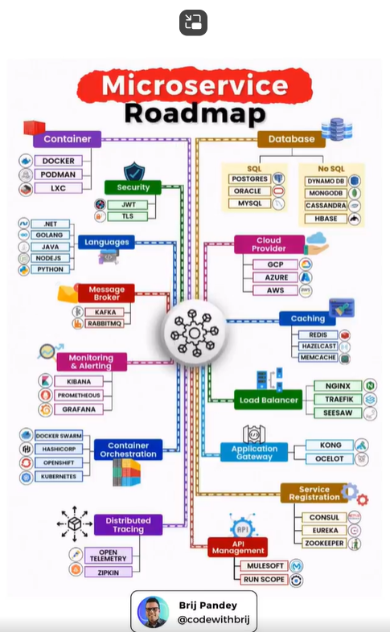

Creating a microservice roadmap involves several key steps and considerations to ensure a successful transition to a microservices [architecture.Here](http://architecture.here/)’s a structured approach to developing your roadmap:  
  
1. Assessment and Planning  
  
- Evaluate Current Architecture: Analyze your existing monolithic application to identify pain points and areas for improvement.  
- Define Goals: Establish clear objectives for adopting microservices, such as improved scalability, faster deployment, or enhanced team autonomy.  
  
2. Design Principles  
  
- Service Identification: Break down the application into distinct services based on business capabilities. Each service should be independently deployable and manageable.  
- Data Management: Decide on a data management strategy, including whether to use a shared database or separate databases for each service.  
  
3. Technology Stack Selection  
  
- Choose Technologies: Select appropriate technologies for building, deploying, and managing microservices (e.g., programming languages, frameworks, databases, and orchestration tools).  
- API Design: Establish standards for API design, including RESTful services or gRPC, to ensure consistent communication between services.  
  
4. Infrastructure Setup  
  
- Containerization: Implement containerization (e.g., Docker) to package services for consistent deployment across environments.  
- Orchestration: Use orchestration tools (e.g., Kubernetes) to manage service deployment, scaling, and networking.  
  
5. Development Practices  
  
- CI/CD Pipeline: Set up continuous integration and continuous deployment (CI/CD) pipelines to automate testing and deployment processes.  
- Monitoring and Logging: Implement monitoring and logging solutions to track service performance and troubleshoot issues.  
  
6. Incremental Migration  
  
- Strangler Pattern: Consider using the strangler pattern to gradually replace parts of the monolith with microservices, allowing for a smoother transition.  
- Pilot Projects: Start with small, non-critical services to gain experience and refine your approach before scaling up.  
  
7. Team Structure and Culture  
  
- Cross-Functional Teams: Organize teams around services, promoting ownership and accountability for specific functionalities.  
- Training and Knowledge Sharing: Invest in training for your teams on microservices principles, tools, and best practices.  
  
8. Feedback and Iteration  
  
- Gather Feedback: Regularly collect feedback from stakeholders and users to assess the effectiveness of the microservices architecture.  
- Iterate and Improve: Continuously refine your services and processes based on feedback and evolving business needs.  
  
9. Long-Term Strategy  
  
- Governance and Standards: Establish governance policies and coding standards to maintain quality and consistency across services.  
- Scaling and Optimization: Plan for scaling services and optimizing performance as the system grows.